# What is Massively Parallel Computer?

SIMD and MIMD are the most commonly used processors in parallel processing.

A number of computers (containing SIMD processors) can be networked together to form a **cluster**. The processor from each computer forms part of a larger pseudo-parallel system which can act like a **super computer**. Sometimes it is refer to as grid computing.

Massively parallel computers have evolved from the linking together of a number of computers, effectively forming one machine with several thousand processors. This was driven by the need to solve increasingly complex problems in the world of science and mathematics.

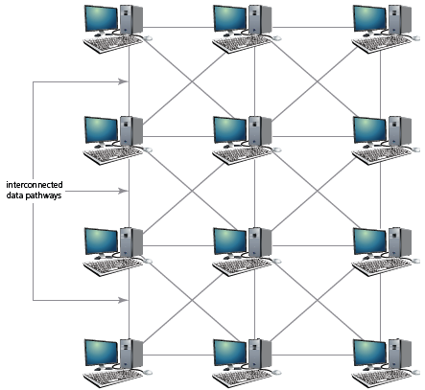 By linking computers (processors) together in this way, it massively increases the processing power of the ‘single machine’. This is subtly different to cluster computers where each computer (processor) remains largely independent. In massively parallel computers, each processor will carry out part of the processing and communication between computers is achieved via interconnected data pathways.

A massively parallel computer is a specialized type of computing system characterized by its ability to employ a large number of processors or processing elements simultaneously in order to execute computations.

These processors, can be in the thousands to even millions, work together to address a given problem. In such a system, each processor typically has its own memory, and communication between these processors is done via a dedicated high-speed interconnect network.

Massively parallel computers refer to a class of computers designed to process tasks using a large number of processors that work together in parallel to perform computations. These machines are built to handle a massive number of instructions and data simultaneously.

Features

* Large Number of Processors: These systems has thousands to millions of processors or processing cores.
* Distributed Memory: Each processor typically has its own memory, and communication between processors is achieved through a high-speed interconnect network.
* Parallel Processing: Operations are performed concurrently by multiple processors, allowing for high computational throughput.
* Specialized Communication Hardware: these computers has dedicated communication hardware, such as high-speed interconnects, to facilitate efficient data exchange between processors.
* Task Decomposition: Problems must be decomposed into smaller, independent subtasks that can be executed simultaneously by different processors.
* Scalability: The system is designed to scale, meaning additional processors can be added to increase computational power.
* Parallel Programming Models: Software for massively parallel computers is typically written using specialized parallel programming models, such as message passing (MPI) or shared-memory (OpenMP), to coordinate tasks and manage data sharing.
* High Computational Throughput: these computers excel at tasks that can be highly parallelized, where many computations can be carried out simultaneously.

These computers are used for tasks that require a tremendous amount of computational power, such as scientific simulations, complex calculations, and big data processing. Examples of applications include climate modeling, nuclear simulations, fluid dynamics, molecular modeling, and certain types of artificial intelligence and machine learning tasks.

Examples of massively parallel computers include

* renowned systems like the IBM Blue Gene series
* Cray XT5/XK6, and, more recently
* GPU-based supercomputers such as those from NVIDIA's Tesla and DGX series.
* Used in scientific exploration and computational-intensive applications,

Advantages

* suitable for processing and analyzing large volumes of data, making them crucial in big data analytics applications.
* Used in training complex machine learning models and executing artificial intelligence algorithms, where the parallel processing capability significantly accelerates training times.

Disadvantages:

* Requires expertise in parallel programming techniques and an understanding of how to effectively distribute tasks among the processors.
* Coordinating tasks across a large number of processors can introduce overhead in terms of synchronization and communication.
* Not all applications can be effectively parallelized. Some tasks are inherently sequential and may not benefit significantly from a massively parallel architecture.
* Building and maintaining massively parallel systems can be expensive, both in terms of hardware costs and the energy required to power and cool the large number of processors.
* Ensuring the reliability and fault tolerance of massively parallel systems can be complex due to the large number of components. Redundancy and fault-tolerant techniques must be carefully implemented.
* In systems with distributed memory architecture, managing data across multiple processors can be challenging and requires careful consideration of data distribution and communication patterns.
* Their individual processors sometimes have lower single-thread performance compared to high-performance single-core processors.